Agenda

*Date: 04/27/13*

*Location: Calit 2, Second Floor*

*Actual Time: 12:30pm - 4:30 pm*

*Planned Length: 1 hour 45 minutes*

***Please add and comment on anything and everything in the agenda!***

|  |  |  |  |
| --- | --- | --- | --- |
| Team Member(s) | Topic | Time | Goals |
| Sorin | Announcements | 5 min | ~~All team members are updated on new developments~~ |
| Sorin | Decide how we’re going to work on the poster for the poster session on Friday | 10 min | ~~Have team members assigned to the creation of the poster; have a date the poster will be created by and sent to the team so they can get familiar with it; ensure there’s team members for the 2-3 section of the poster session~~ |
| All | Set up coding environment (Bring your laptop) | 30 min | All team members can use git, download and change code, and push to the repository successfully. |
| All | Choose subteams | 15 min | ~~All team members have a subteam they are on and this data is recorded in a visible place like the team contact sheet~~ |
| All | Lay out overall architecture/flow of control | 10 min | All team members understand an overview and flow of control of the program we’re looking to build; This data is recorded in a visible place like github |
| All | Update Scrumy board with next tasks | 15 min | Scrumy board contains all tasks relevant to this quarter written in atomic chunks; team members can later assign themselves a task and move the post-it according to their progress |
| Sorin | Recap and Next steps | 5 min. | Meeting progress/ goal accomplishment is recapped. Next steps are outlined so that every team member goes into next week knowing what they are expected to contribute |

**Time total:** 5 + 10 + 30 + 15 + 10 + 15 + 5 +15(chat time) = 100 = **1 hour 45 minutes**

# Notes

Web application or native application? Do they have internet access?

<http://www.tutorialspoint.com/python/python_gui_programming.htm>

^-- Python GUI Programming

<http://wiki.python.org/moin/GuiProgramming>

* Solution: Django with no internet access, deploy for client over localhost.

**Subteams**

**Frontend**

* Andrew
* John
* Dorothy (open to both)
* Heather (open to both)
* Carter (maybe)

**Backend**

* Shannon
* Kevin
* Brian
* Sorin
* JT
* David (open to both)

David will compile the poster

Dorothy will write up a summary of the frontend subteam, update

**Front End Tasks**

* Finish user stories and a flow of control of the program(from the user perspective)
* Send user stories and flow of control to client for approval
* Wireframe UI
* Create UI
  + User can redefine eye regions

**Back End Tasks**

* test on photos of autistic kids - Brian
* Script to rotate photos - David
* Fix pointer errors in eye detection script. - Shannon
  + beef error throwing/ detection
* Fix nostril detection in eye script - Kevin
  + In upper half of face
  + same size ish
  + on a horizontal line
* Write script to take in a picture and two regions and output a left.jpg and right.jpg - JT
  + then to sclera analysis
* script to take in a picture and get the pupil
  + then to cataracts analysis or crescent analysis
* script to take in a pupil and detect the crescent
* pupil to analyze the crescent for disease

Model Layer

* Objects to pass along
* Person has a horizontal and a vertical
* horizontal and vertical extend Pictures
* Pictures has a left has a right.

For vertical pictures have button to say it’s vertical so we can rotate first.

Key point for user crescent specification like Dorothy’s makeup app

# Summary/Progress *(one to one mapping with goals)*

* No Announcements
* David will compile the poster
* All members that brought their laptop and have windows got it working.
* Subteams chosen (see notes)
* Shannon will layout software architecture and send it out
* At least the backend team updated scrumy ( I don’t know about front end)
* Follow MVC Architecture
  + Model: Objects that the backend team writes
  + Controller: Logic the backend team writes
  + View: Everything the front end team writes (UI and templates)

White Board Pics

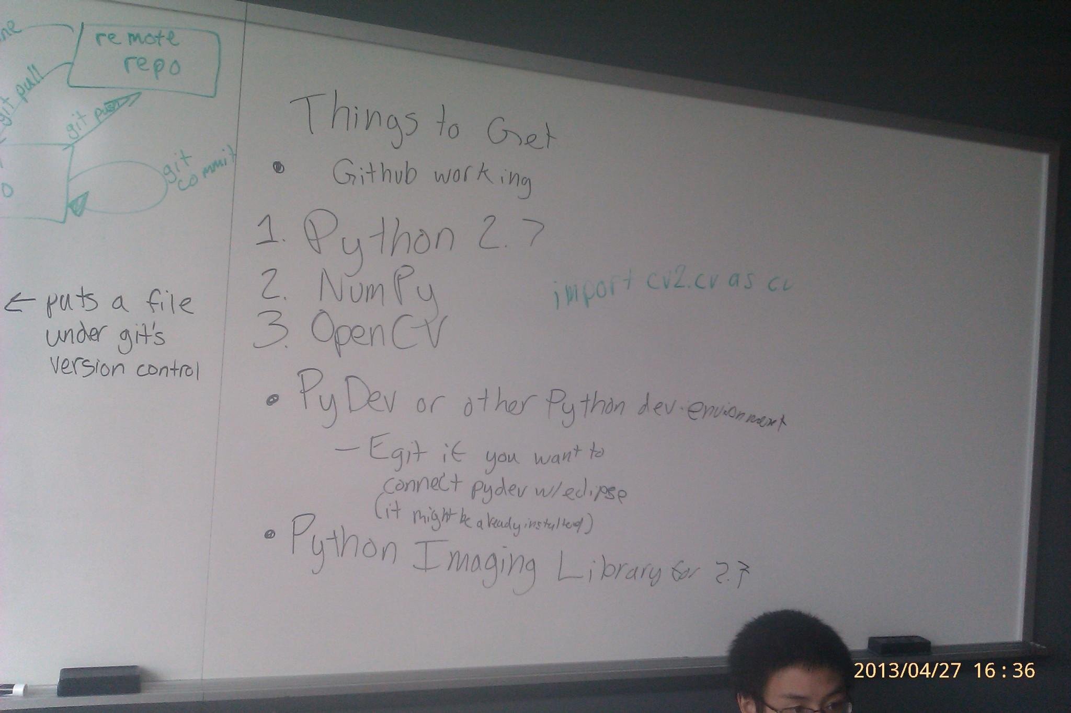

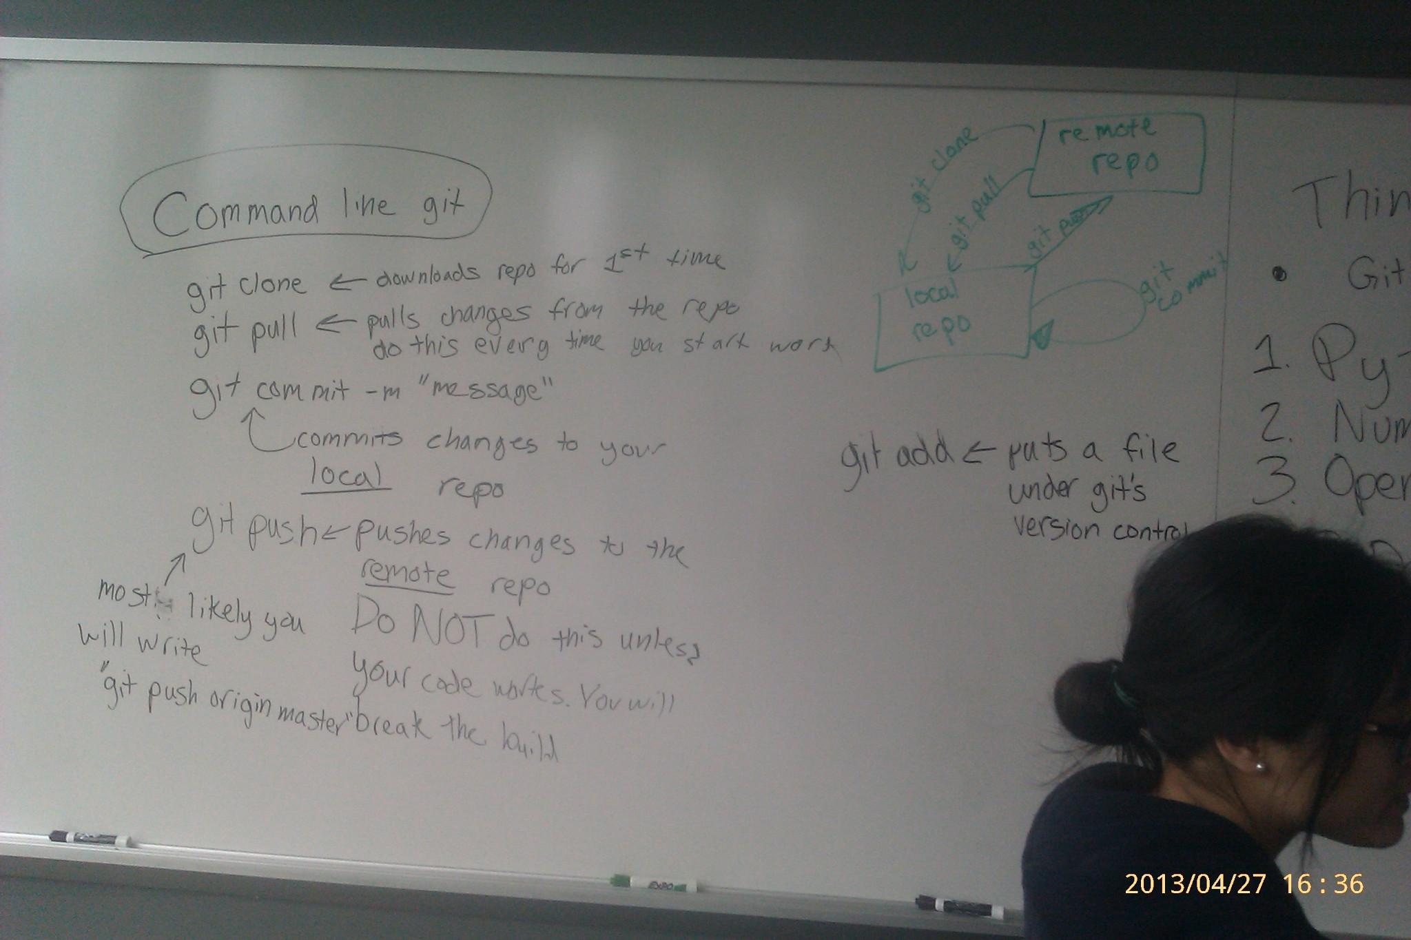

GUI - FLOW MANAGMENT:

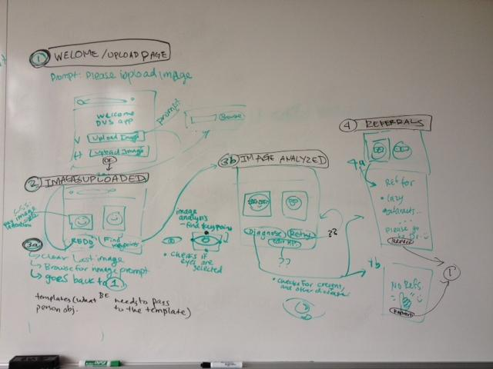

# TODO

* David: Compile poster for Friday.
* Dorothy:
  + Write summary of frontend subteam
  + Update Website with Subteams and subteam goals

**Front End Tasks**

* Finish user stories and a flow of control of the program(from the user perspective)
* Send user stories and flow of control to client for approval
* Wireframe UI
* Create UI
  + User can redefine eye regions

**Back End Tasks**

* test on photos of autistic kids - Brian
* Script to rotate photos - David
* Fix pointer errors in eye detection script. - Shannon
  + beef error throwing/ detection
  + IO errors
  + Pointer errors
* Fix nostril detection in eye script - Kevin
  + In upper half of face
  + same size ish
  + on a horizontal line
* Write script to take in a picture and two regions and output a left.jpg and right.jpg - JT
  + then to sclera analysis
* script to take in a picture and get the pupil
  + then to cataracts analysis or crescent analysis
* script to take in a pupil and detect the crescent
* pupil to analyze the crescent for disease

OpenCV problems:

<http://luugiathuy.com/2011/02/setup-opencv-for-python/>

<http://www.pythonware.com/products/pil/>

--> click this! [**Python Imaging Library 1.1.7 for Python 2.7**](http://effbot.org/downloads/PIL-1.1.7.win32-py2.7.exe) (Windows only)